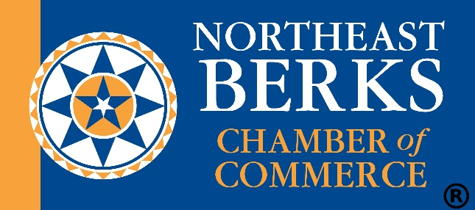

ADMINISTRATIVE ASSISTANT
JOB DESCRIPTION

The Administrative Assistant provides on-site office support 10 hours a week for the Northeast Berks Chamber of Commerce, Kutztown, PA, specifically in the areas of marketing support, bookkeeping, and office/membership support under the supervision of the Executive Director.

In this role, responsibilities may include:

Marketing Support
- Chamber Website (WordPress)
  - Update Google Calendar, new member listings, and event postings
- Constant Contact
  - Collect content and image files to produce biweekly e-news for chamber members
- Graphic Design, Photography a PLUS
Bookkeeping
- Use QB to track all income and expenses; update customers, issue invoices, and generate reports

Office/Membership Support
- Coordinate new and prospective member processes, including workflow for Salesforce, QuickBooks, and Constant Contact
- Coordinate registration process for all chamber programs and events
- Assist with special projects, as assigned

NOTE: The list of essential functions is not exhaustive. It may be supplemented as necessary. The hourly rate is competitive.

Submit resumes with cover letters to Lori B. Donofrio-Galley, Executive Director, at ldg@northeastberkschamber.com.

